|  |
| --- |
| Employee |
| -employeeName: String  -age: Integer  -gender: ENUM  -dateOfBirth: String  -passportNumber: String  -employeeIDNumber: String  -department: ENUM  -jobTitle: ENUM  -basicSalary: Float |
| +setEmployeeName(employeeName: String)  + getEmployeeName():String  + setAge(age: Integer)  + getAge():Integer  + setGender(gender: ENUM)  + getGender():ENUM  + setDateOfBirth(dateOfBirth: String)  + getDateOfBirth():String  + setPassportNumber(passportNumber: String)  + getPassportNumber():String  + setEmployeeIdNumber(employeeIDNumber: String)  + getEmployeeIdNumber():String  +setDepartment(department: ENUM)  + getDepartment():ENUM  + setJobTitle(jobTitle: ENUM)  + getJobTitle():ENUM  + setBasicSalary(basicSalary: Float)  + getBasicSalary():Float  +displayInfo() |

|  |
| --- |
| Manager |
| -salespersons: List  -company: Company |
| + setSalespersons(salespersons: List)  + getSalespersons():List  + setCompany(company: Company)  + getCompany():Company  +displayInfo() |

|  |
| --- |
| Salesperson |
| -manager: Manager  -sales: List |
| + setManager manager: Manager)  + getManager():Manager  + setSales (sales: List)  + getSales():List  +displayInfo()  + calculate_salary(car, salePrice) |

|  |
| --- |
| Company |
| -companyName: String  -employees: List  -cars: List  -sales: List  - revenue: Float |
| + setCompanyName companyName: String)  + getCompanyName():String  + setEmployees (employees: List)  + getEmployees():List  + setCars(cars: List)  + getCars():List  + setSales (sales: List)  + getSales():List  + setRevenue(revenue: Float)  + getRevenue():Float  +displayInfo()  +getEmployeeDetails(employeeIDNumber)  +getCarDetails(carIDNumber)  +displaySalesDetails(employeeIDNumber)  +save_data()  +load_data() |

|  |
| --- |
| Customer |
| -firstName: String  -lastName: String  -customerIdNumber: String  -gender: ENUM  -phoneNumber: String |
| + setFirstName(firstName: String)  + getFirstName():String  + setLastName(lastName: String)  + getLastName():String  + setCustomerIdNumber(customerIdNumber: String)  + getCustomerIdNumber():String  + setGender(gender: ENUM)  + getGender():ENUM  + setPhoneNumber(phoneNumber: String)  + getPhoneNumber():String  +displayInfo() |

|  |
| --- |
| Car |
| -carName: String  -carIdNumber: String  -price: Float  - carType: ENUM  -fuelCapacity: Float  -year: Integer  -maxSpeed: Float  - color: ENUM |
| + setCarName(carName: String)  + getCarName():String  + setCarIdNumber(carIdNumber: String)  + getCarIdNumber():String  + setPrice(price: Float)  + getPrice():Float  + setCarType(carType: ENUM)  + getCarType():ENUM  + setFuelCapacity(fuelCapacity: Float)  + getFuelCapacity():Float  + setYear(year: Integer)  + getYear():Integer  + setMaxSpeed(maxSpeed: Float)  + getMaxSpeed():Float  + setColor(color: ENUM)  + getColor():ENUM  +displayInfo() |

|  |
| --- |
| Sales |
| -salesperson: Salesperson  -car: String  -salePrice: Float  - customer: Customer  - salespersonAmount: Float |
| + setSalesPerson(salesperson: Salesperson)  + getSalesPerson():Salesperson  + setCar(car: String)  + getCar():String  + setSalePrice(salePrice: Float)  + getSalePrice():Float  + setCustomer(customer: Customer)  + setCustomer():Customer  + setSalespersonAmount(salespersonAmount: Float)  + getSalespersonAmount():Float  +displayInfo() |

1

*



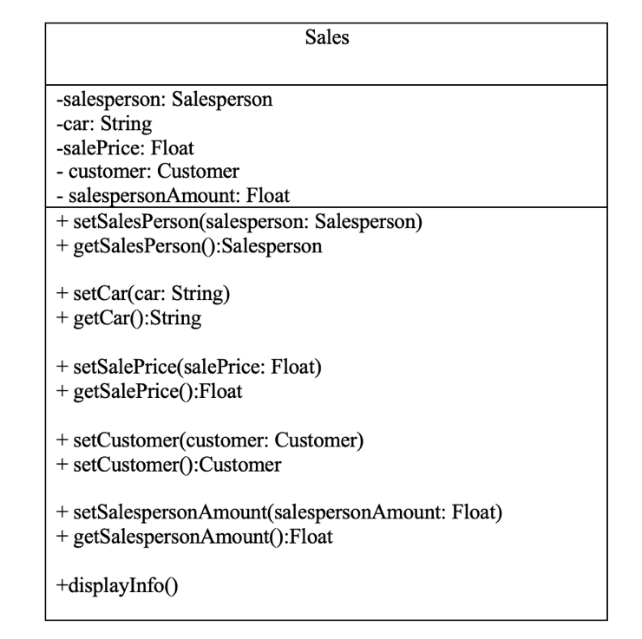

*

1

*

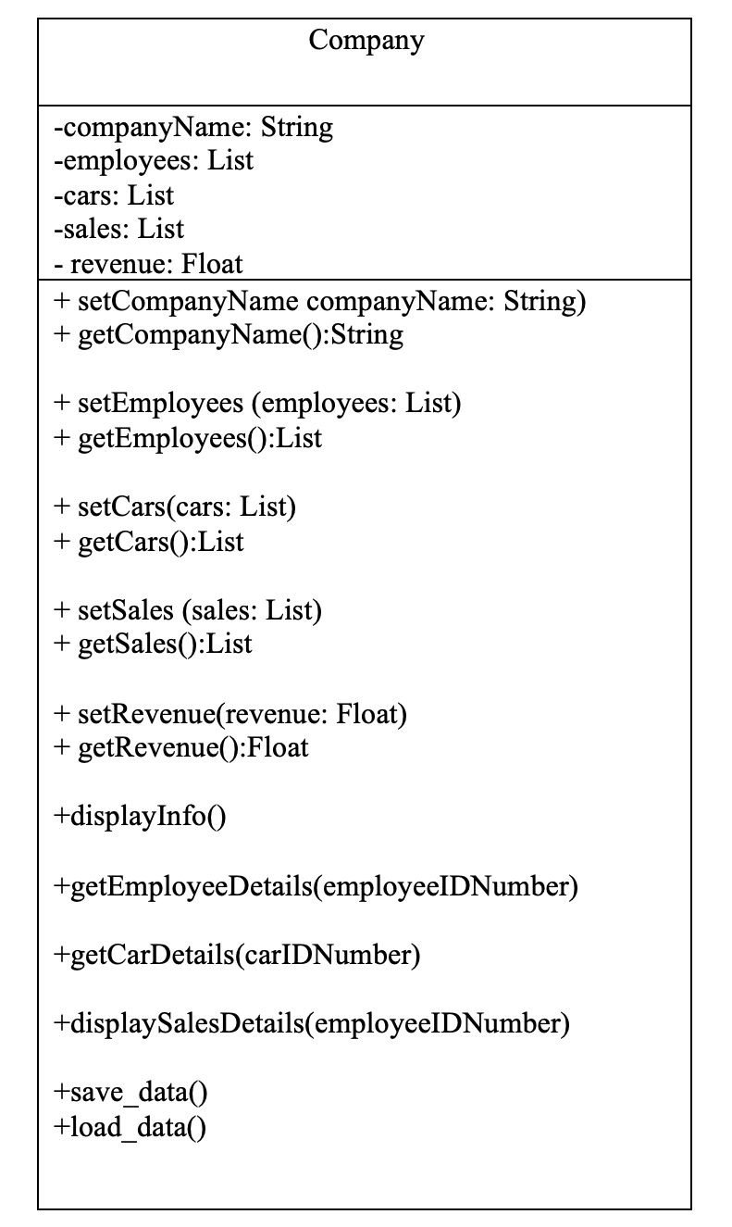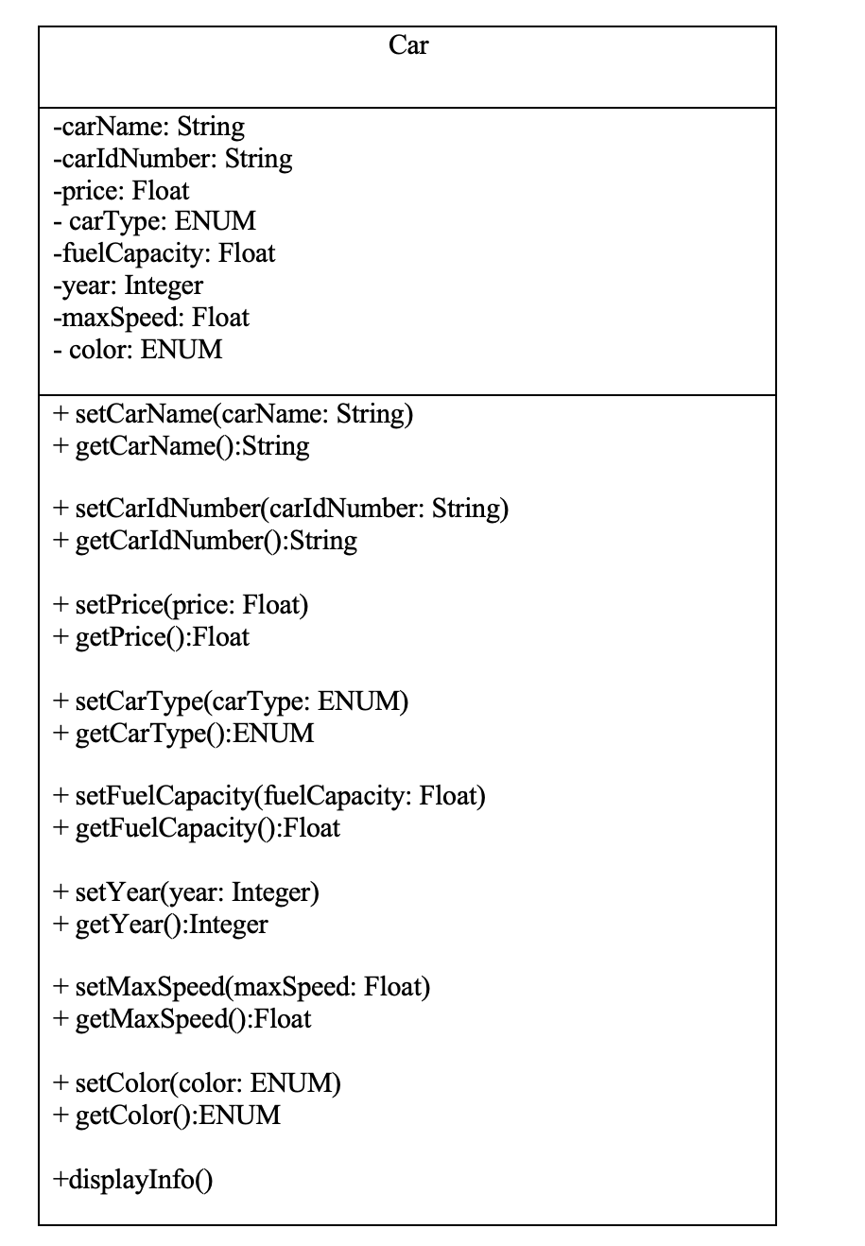

*

1

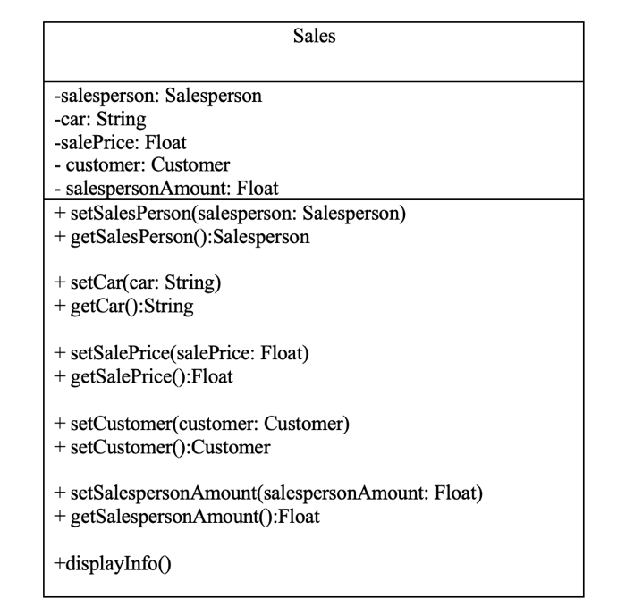

1

1



